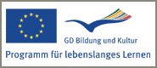
Informationstechnologie-Lösungen
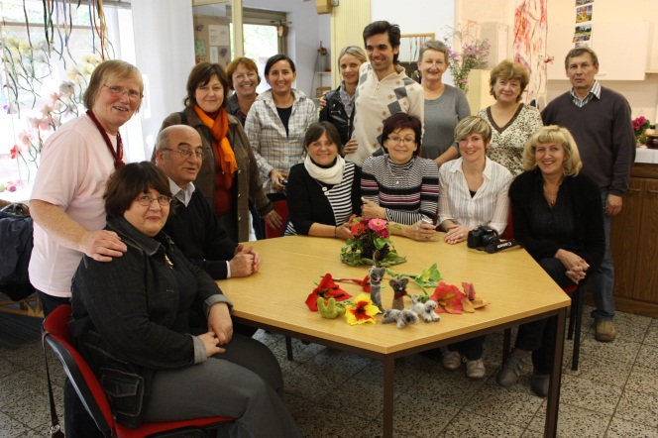
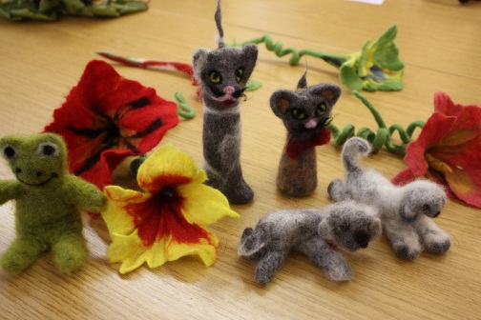
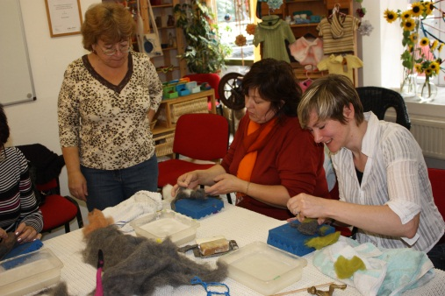
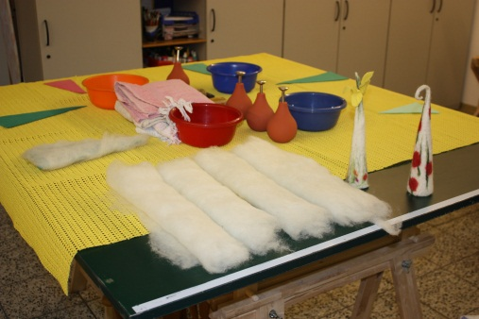
The benefit of the YOCAIT project

The aim of the two years partnership is the exchange of experiences in start-up and management practices as well as creative work methods in crafts & trade at a transnational level.

The project brings these two aspects together and supports self-entrepreneurship of disadvantaged women in an innovative way.

Targeted women should get new opportunities of creating self-entrepreneurship using their creative skills for incidental earnings and through the flexible time get a better work life balance.

For further information please visit our website http://businessthroughcreativityyocait.weebly.com/
Nr. 1/December 2010

CONTENT

Introduction of the YOCAIT project

The benefit of the YOCAIT project

Market of Cultures
“Let´s Christmas” – Christmas traditions in partner countries

Introduction of the YOCAIT project partners

NEWS
Welcome to the YOCAIT project http://businessthroughcreativityyocait.weebly.com/
The 2nd project meeting will take place between 9th and 11th of February 2011 in Samokov, Bulgaria

Check out the New Christmas assortment in Stoff-Kreationen online shop.
Find out more on www.stoff-kreationen .de

Welcome to the first YOCAIT Newsletter!
The European Project “You can do it! – motivate women to have own businesses” (YOCAIT) is a project funded within the Grundtvig Learning Partnership program of the European Union. The project team consists of seven European Partners from Germany,

Czech Republic, Turkey, Hungary, Italy, Lithuania, France, Bulgaria and Estonia.
Photos: Workshop at the association Naomi e.V.
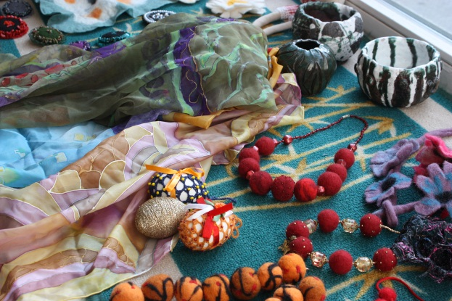

The YOCAIT Newsletter will be published quarterly.
In each edition we will introduce country specific handicrafts and traditional working techniques. This allows you to get to know the project countries from their creative side and maybe get impressions for your own work.

Christmas decorations from Czech Republic
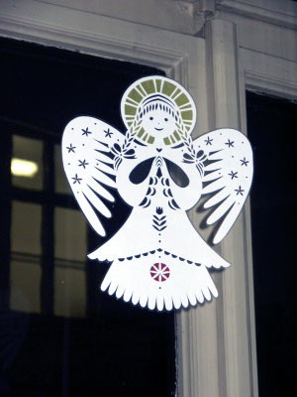
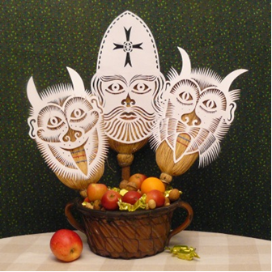
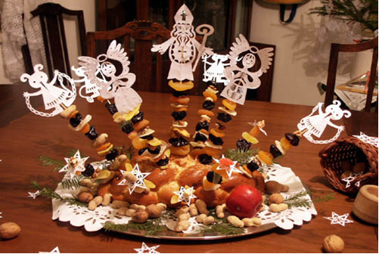
Kick-Off Meeting in Leipzig

The kick-off meeting took place between 4th and 6th of October 2010 in Leipzig, Germany.

The three day project meeting included upon others different study visits in creative workshops in the city of Leipzig.

***

The European project partners got the opportunity to visit the Keramikwerstatt andrea doria e.V. which are offering different ceramic workshops for children and adults, as RAKU-workshop - a special burning technique originating from Japan or workshops offered for laymen to experimentalise with clay and glaze.
URL: http://www.andrea-doria-ev.de/home.html)

***

Ms. Siegrid Müller, the owner of the online shop “Stoffkreationen” was invited to talk about her challenges and experiences by creating her small online shop
URL: http://www.shop-014.de/shop-landtraum.html

Market of cultures
5th December starts the Czech traditional Christmas atmosphere with St. Nicholas, Angel and Devil who visit children to evaluate their good and bad way of behavior.

24th December is the Christmas celebration. In the old times people fasted all day with the aim to see the “gold pig” in the evening.
Today, people eat carp with potato salad for Christmas dinner. Under the Christmas tree everyone finds some gift from Father Christmas.

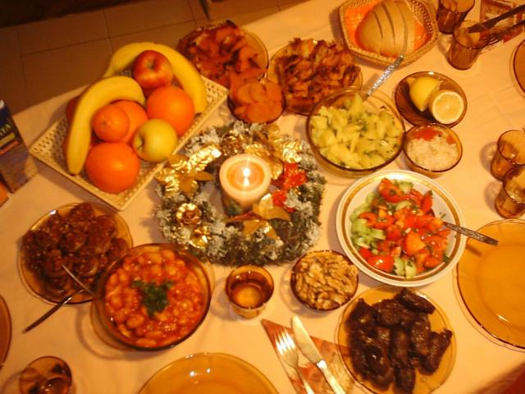
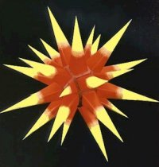
Bulgarian Christmas Tradition
The Budnik symbolizes the Tree of Life - an archetypal image of the Universe. The predecessors believed that the ashes of the Budnik possessed magical power. They used to scatter portions of it over the corn-fields - for abundance of crops; they put pinches of it in the food of the domestic animals for health and fertility. When the Budnik was lit up, the head of the family had to go out in the yard and to, loudly, invite God to join the table: "Come, God, have dinner with us!“

Christmas Eve in Bulgaria is called Budni vecher. According to the old Bulgarian tradition, one of the single young men in the family had to cut a huge piece of a trunk, to wrap it with a white piece of cloth and carry it into the house. That piece of wood was called Budnik (budeshte in Bulgarian means future.)
The menu on Budni vecher is rich but it consists only of vegetarian meals. Their number should be odd and they should not be less than 7 - peppers, stuffed with old beans or pieces of leek; “sarmi” made out of cabbage or vine-leaves; old beans, dried fruits, honey, walnuts. Let's not forget the garlic! It keeps away the evil spirits, which might decide to join the party.

The “Herrnhuter Stern” was founded by the Protestant Moravian Church in Upper Lusatia. According to the old custom the star is prepared in the circle of family and friends and hung up on the 1st Sunday in Advent. 150 years ago an educator began to tinker a star from cardboard and paper as a lighting fixture. Soon, the students produced the stars by themselves which helped them to overcome the time living in a boarding school and being away from their parents during the Christmas season.
German Traditional Christmas Decoration
„Herrnhuter Stern“

Kick-Off Meeting in Leipzig

Mr. Wennemar de Weldige from the City of Leipzig, Department of business development informed the participants of the kick-off meeting about requirements for set-ups of micro-businesses as well as about possible grants.

***

Sister Gudrun from Naomi e.V. welcomed the YOCAIT project partners in “Kreativstube” (creative room). Naomi e.V. offers creative courses for disadvantaged women. The aim is to support their social integration in the society, to engage them to work creatively and to foster them to use their time meaningful.
URL: http://www.naomi-leipzig.de/

***

Werkstatt des Lichts, a small shop, making candles, to get to know more about set up of small businesses in the field of handcraft. Mr. Wolf operates also an additional online-shop where interested people can buy
different kinds of candles
URL:http://shop.werkstatt-des-lichts.de/).

How to make Herrnhuter Stern? Visit http://businessthroughcreativityyocait.weebly.com/

Informationstechnologie-Lösungen

European Partnership

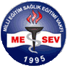MESEV takes an active role in the vocational education and training but offers also management seminars and consulting for adults. MESEV is active in local, regional and international projects.. For more information please visit www.mesev.org

Contact Person:
Mr. Hasan Er
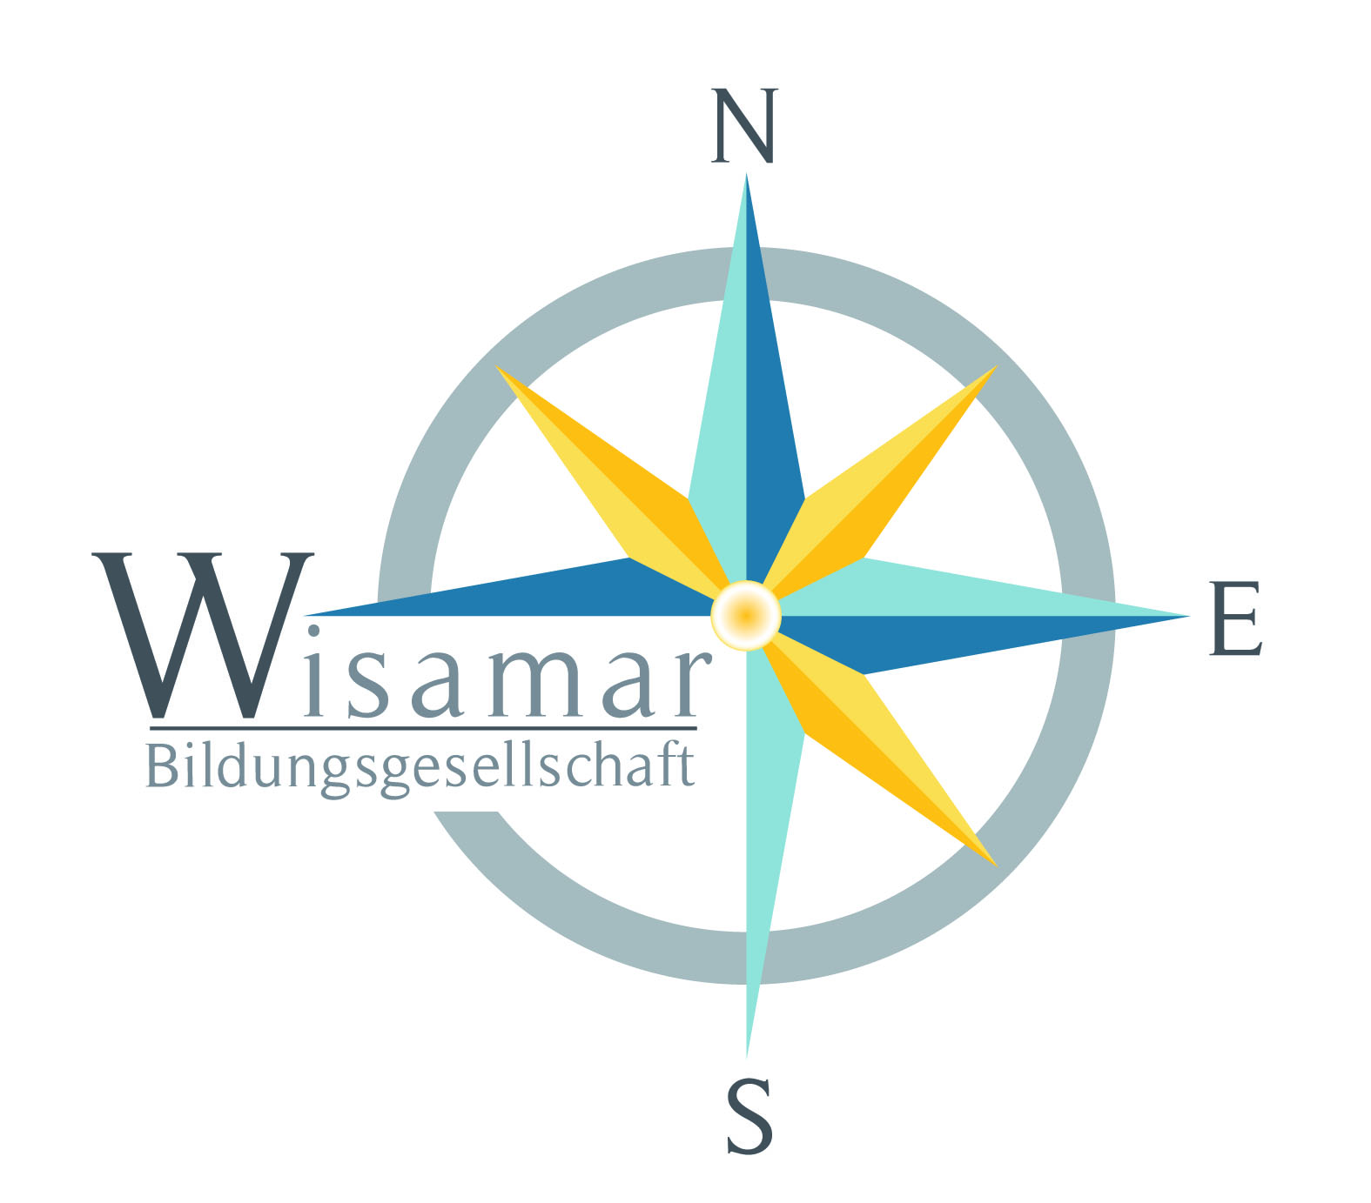wisamar Bildungsgesellschaft is located in Leipzig, Germany. It provides consultancy, coordination of educational projects mainly on a European level, as well as further education. For more information please visit www.wisamar.de

Contact Person:
Ms. Eszter Csepe
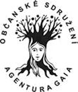Agentura GAIA is a civic association that seeks ways to cultivate new attitudes toward the environment, equal rights, and alternatives to consumption life style. For more information please visit www.quovadisfemina.cz.

Contact Person:
Ms. Marie Haisová

For further information about the project activities as well as about the partners please visit our website http://businessthroughcreativityyocait.weebly.com/

Please visit our website http://businessthroughcreativityyocait.weebly.com/ for further descriptions of country specific Christmas habits as well as of traditional handcrafts. You will find on the website also some instructions for creating nice Christmas decorations.

If you are interested in the cooperation with us within the YOCAIT project please contact Ms. Eszter Csepe eszter.csepe@wisamar.de

We welcome your creative contribution to the content of the project and support the European wide networking in the field of creativity and handcraft.

Wisamar Bildungsgesellschaft mbH
Heinrichstrasse 39/41
04317 Leipzig
Germany
Tel.: +49 (0) 341 6877 682
Fax.: +49 (0) 341 6981328
www.wisamar.de

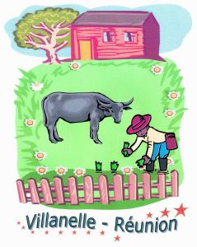Villanelle Reunion aims at launching and developing educational programs in partnership with other local institutions. The association plays an active role in animating social and cultural life in favor of local population. For further information please visit www.villanelle-reunion.fr

Contact Person:
Mr. Harry Malet

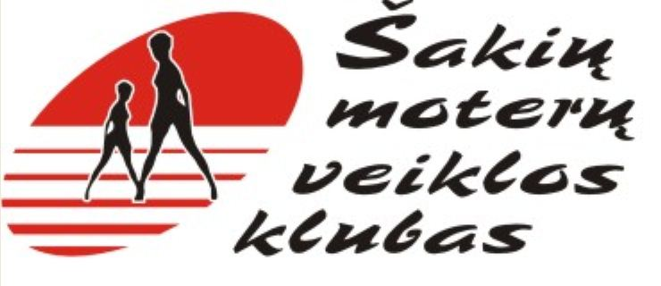
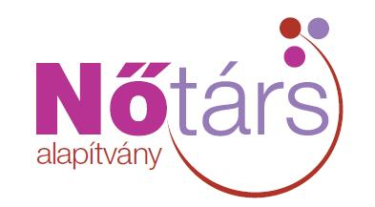
Notars Fundation´s mission are to strengthen and continually develop women´s enterprises by cooperating with non-governmental organizations, firms and volunteers by means of trainings, programs, partnerships, networks, etc. For further information please visit www.notars.hu

Contact Person:
Ms. Ildiko Sarkozy
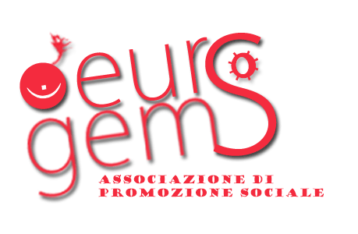
Eurogems is a non-profit organization. Its aims are to manage activities in which youngsters and adults can meet themselves, know each other and socialize for civil society empowerment. It promotes ICT and media. For further information please visit www.eurogems.eu

Contact Person:
Mr. Simone Caramel
Women´s Activity Club of Sakiai aims to solve women´s occupation, qualification and social problems, develop women´s self-expression, and encourage self-sufficiency and creativity. The Club organizes trainings, cultural events, exhibitions.

Contact Person:
Ms. Aurelija Grinkevičienė
LPPBA

Legal Protection Public Benefit Association with extensive knowledge and experience in the fields of managements, economics and law, determined to assist the sustainable social, economic, cultural and educational development.

Contact Person:
Ms. Irena Ignatova-Koen


Mittetulundusühing Euro Kalliskivid operates in a socially and geographically disadvantaged rural area. It favors educational activities and vocational training involving the local community. The organization acts to create EU projects. For further information please visit http://www.eurokalliskividmtu.tk
Contact Person:
Mr. Christian Cappelletto

